**CREATING BOOK PAGES WITH ITS DETAILS AND TEMPLATES**

**Creating Book components:**

**HTML :**

<sly data-sly-use.clientLib="/libs/granite/sightly/templates/clientlib.html" />

<sly data-sly-call="${clientLib.css @ categories='bookdetails'}" />

<div class="book-details">

<h2 class="book-title">${properties.title}</h2>

<sly data-sly-test.hasImage="${properties.coverimage}">

<img class="book-cover" src="${properties.coverimage}" alt="${properties.title}">

</sly>

<p class="book-description">${properties.description}</p>

<p class="book-author">Author: ${properties.author}</p>

</div>

**CSS :**

.book-details {

max-width: 600px;

margin: 20px auto;

padding: 20px;

background: #fff;

border-radius: 10px;

box-shadow: 0 4px 8px rgba(0, 0, 0, 0.1);

text-align: center;

}

.book-title {

font-size: 24px;

font-weight: bold;

color: #333;

margin-bottom: 10px;

}

.book-cover {

width: 100%;

height: auto;

max-height: 350px;

object-fit: contain;

border-radius: 8px;

margin-bottom: 15px;

}

.book-description {

font-size: 16px;

color: #555;

margin-bottom: 10px;

}

.book-author {

font-size: 14px;

font-weight: bold;

color: #007bff;

}

**Creating a Template:**

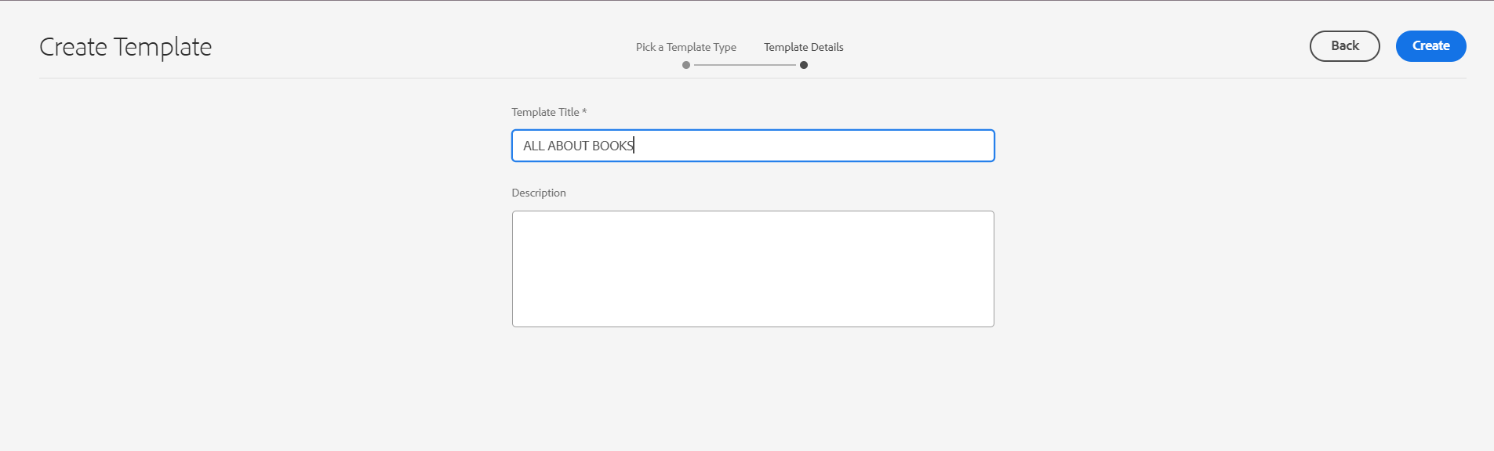

**Editing the Header and Footer of the template :**

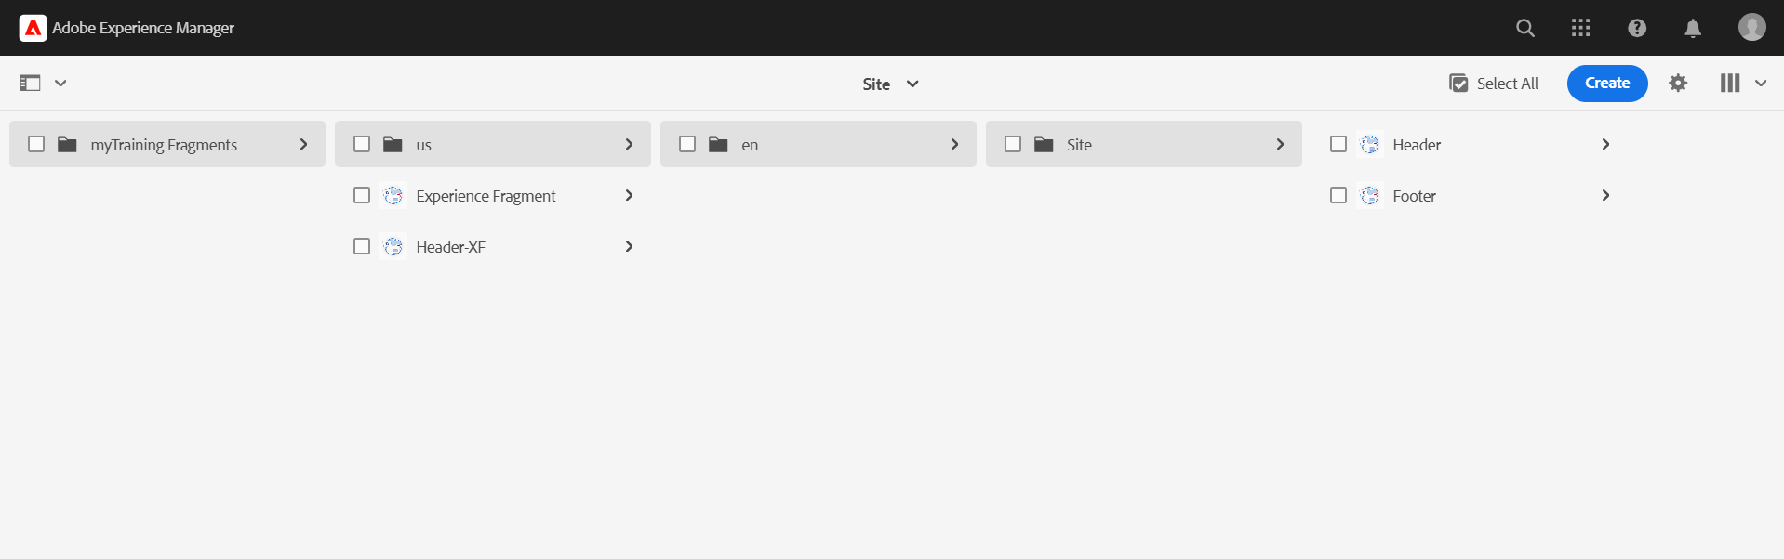

**HEADER:**

* Added image , list and text components for logo, pages list and reach us .

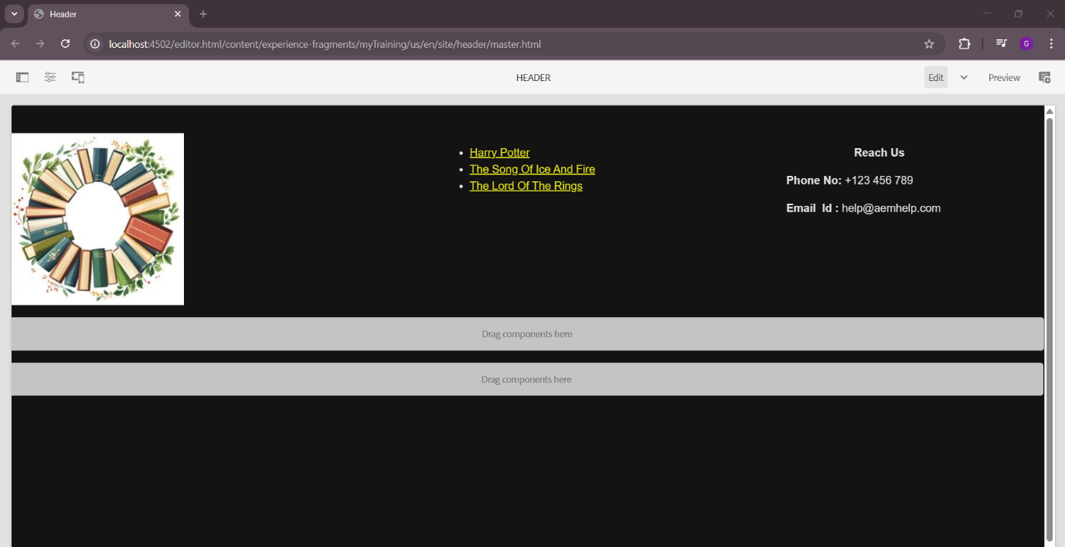

**FOOTER:**

* Created Footer with list and text components to add list of pages , about us , reach us, and copyrights.

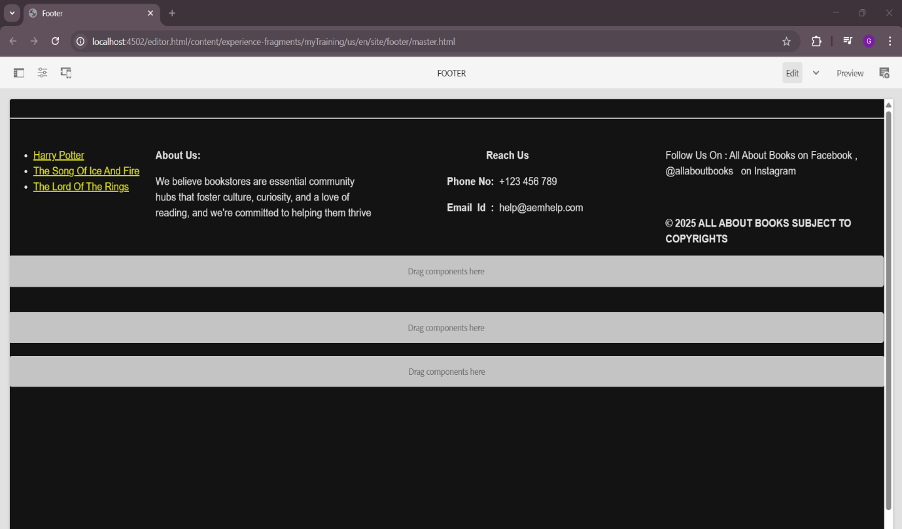

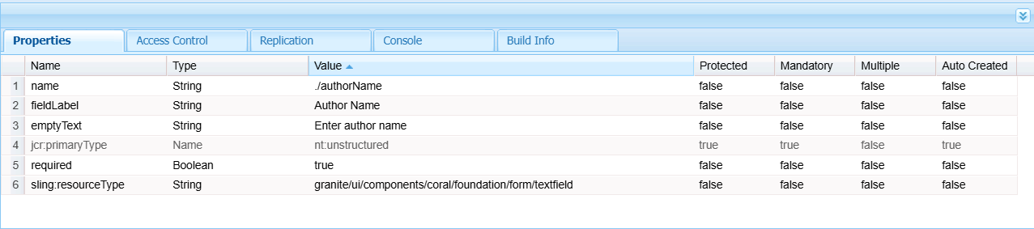

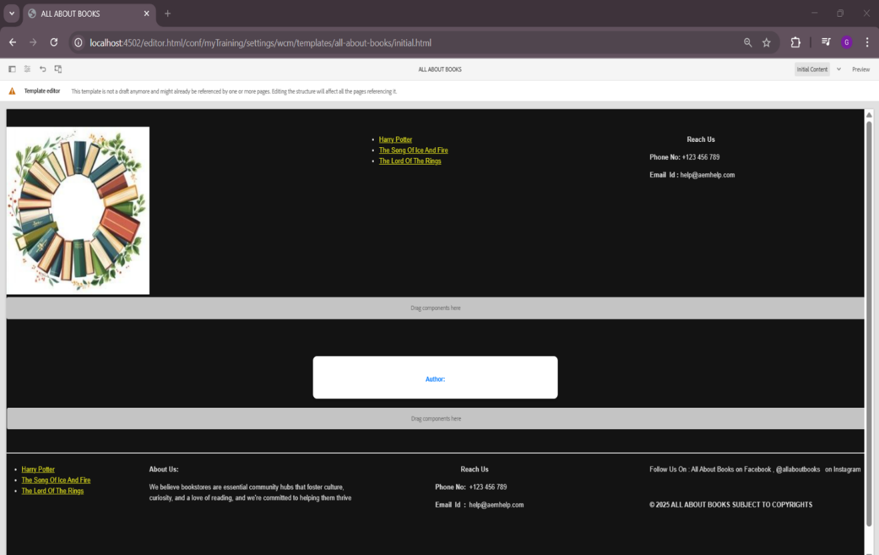**Adding Book Details Component :**

**Creating List of 10 Pages :**

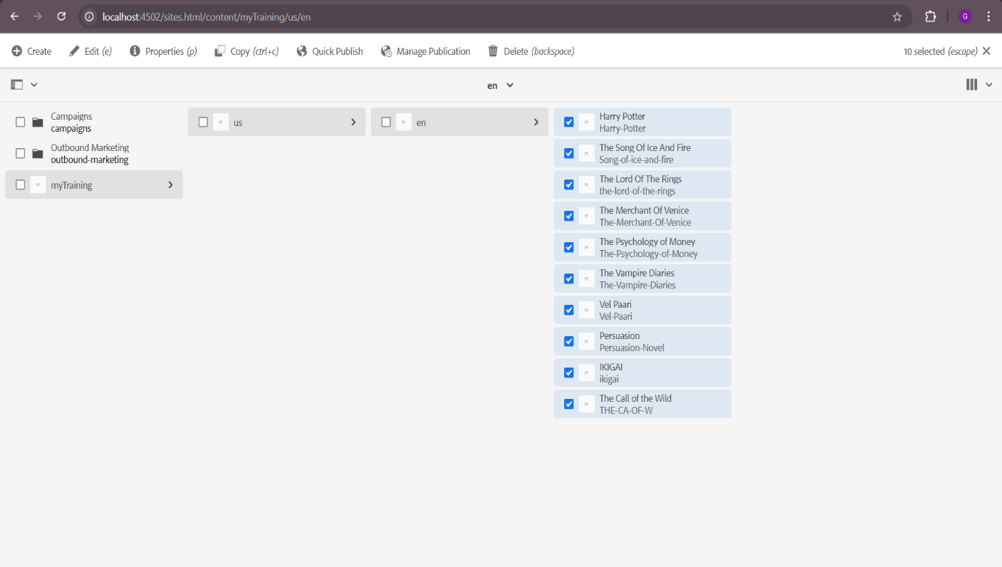

**Using the Book Details Componet :**

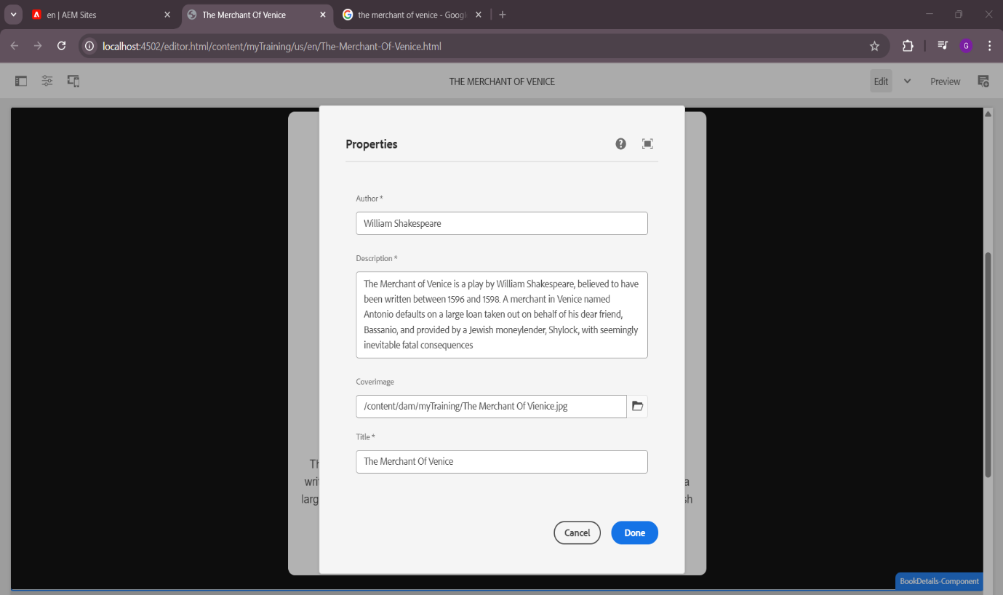

**Result:**

